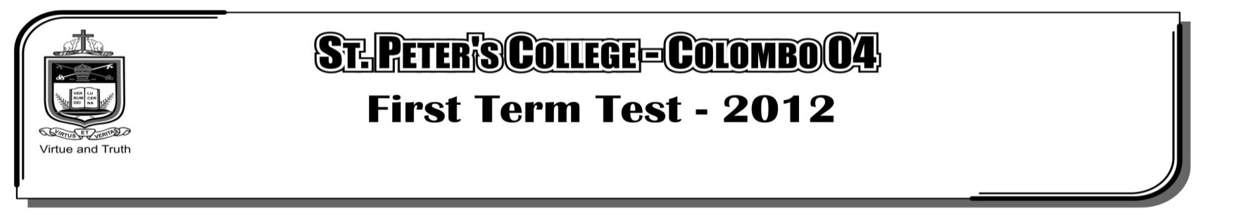

**FIRST TERM TEST - 2019**

**GRADE 10 – Physical Education**

**Part II**

**Answer all the questions.**

01. i. What is known as “correct posture”?

ii. What are the factors that you should consider when in a correct standing posture?

iii. What factors should be considered when sitting on a chair correctly?

iv. Write 04 harmful effects of bad posture? **(1+2+3+4=10 Marks)**

02. i. What is the “centre of gravity”?

ii. What are the two main bio mechanical factors related to posture?

iii. Explain what is “Balance”

iv. Write 03 factors that help to maintain balance in physical activity? **(2+2+3+3=10 Marks)**

03. i. Write 04 skills found in volleyball?

ii. How many referees are required to officiate a volleyball match? Name them.

iii. Draw a diagram and show how (both teams) should take positions in the court at the start of a

netball game?

iv. Write 04 ways of controlling the ball in football? **(2+2+3+3=10 Marks)**